Directions for Creating a Digital Signature in Adobe
- Open the PDF in Adobe Reader.
- Click on the Signature line that you need to sign.
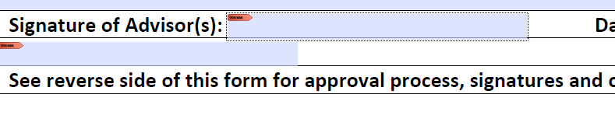
- Click the “Create a new Digital ID”, then click continue.
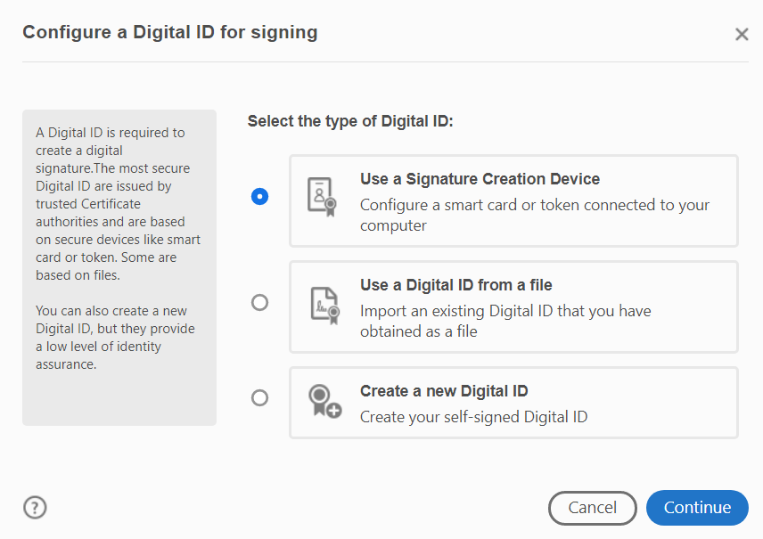
- Fill in the name that you want on the document & your email address. Click Save.
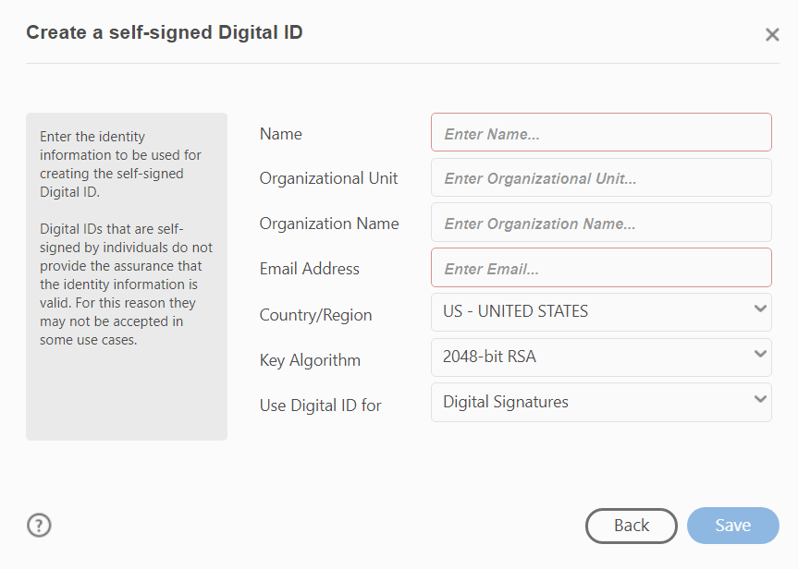

- Click “Save to File”, and click continue.
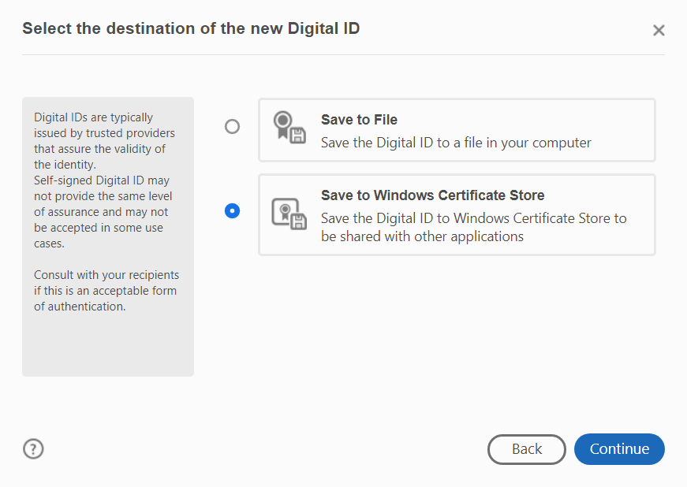
- Click on the Digital ID that you want to sign document with, then click continue.
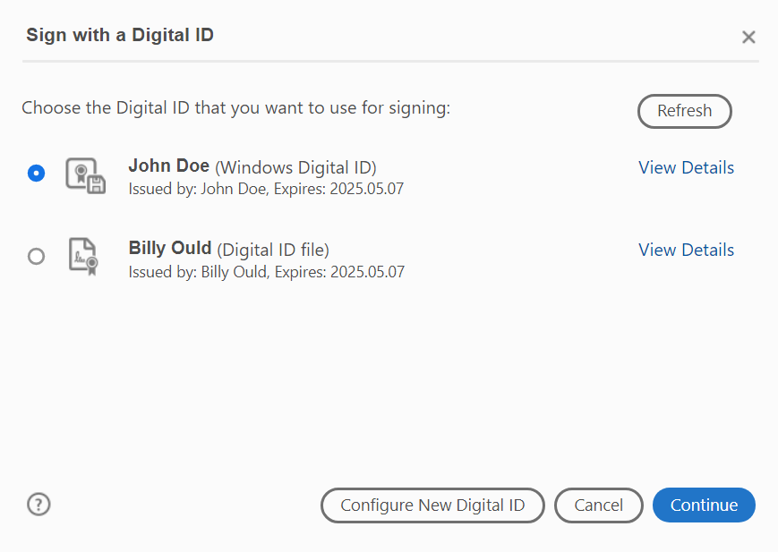

- Review and click Sign.
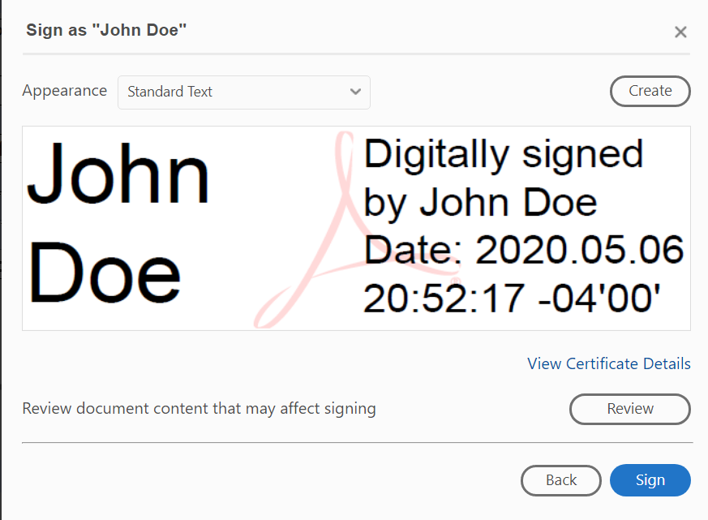
- Choose where to save the document.

- Signed document.
